1)
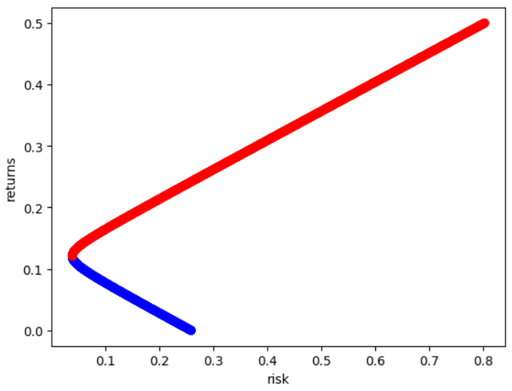
a)

b)
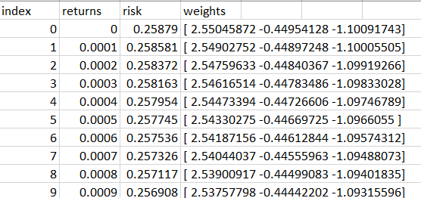

c)two returns are possible:0.0524 and 0.1896
d)


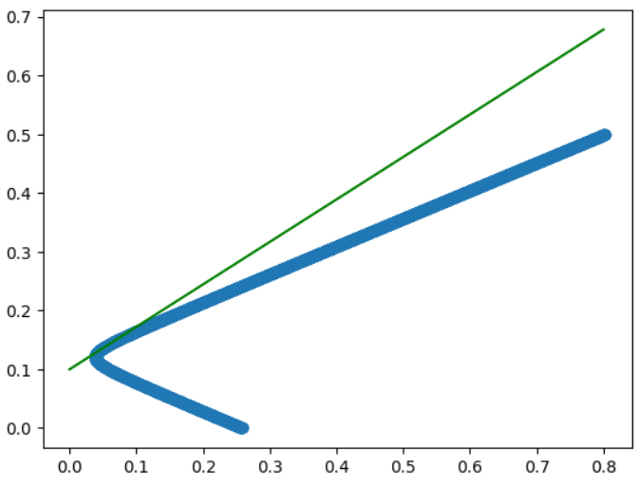
e)

market portfolio:[0.0508,0.1367]

f)

2)

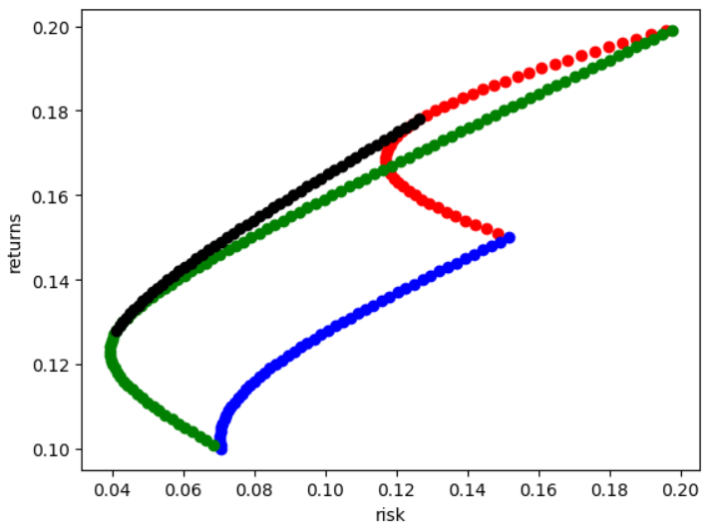
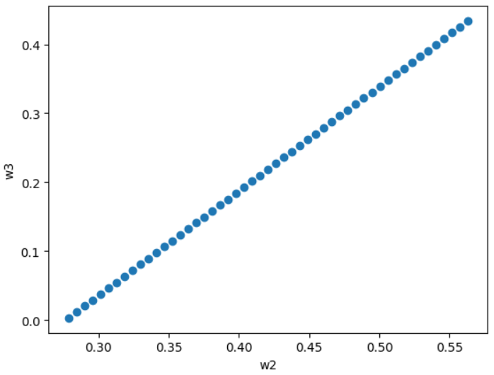
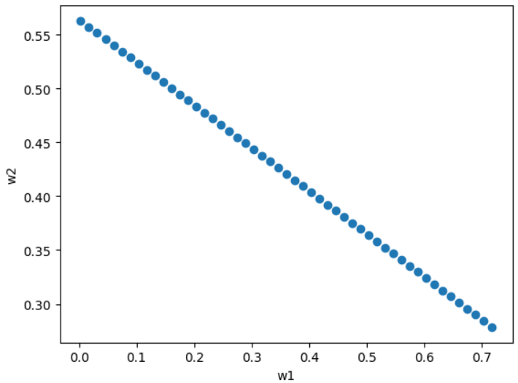

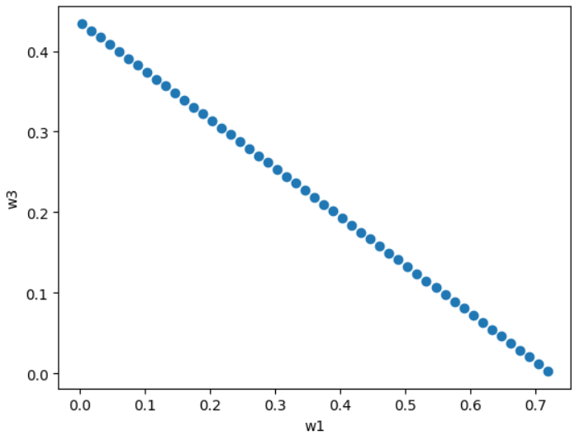

The equations are:
w2=-0.40*w1+0.56
w3=1.52*w2-0.42
w3=-0.60*w1+0.44

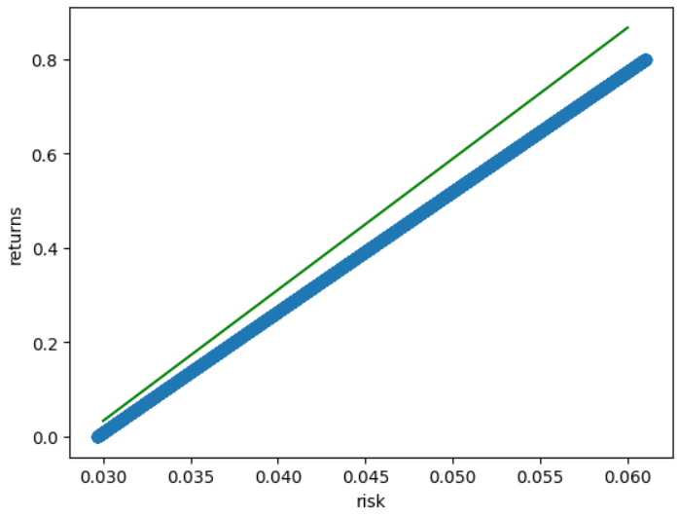
3)a)c)the green line is the CAPM line
the blue line is min variance portfolio curve(it almost seems like a line because the small covariance values of the data extracted)

I had to take risk free return rate( µ_{rf}) to be -0.8 in the whole duration.

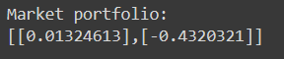
b)

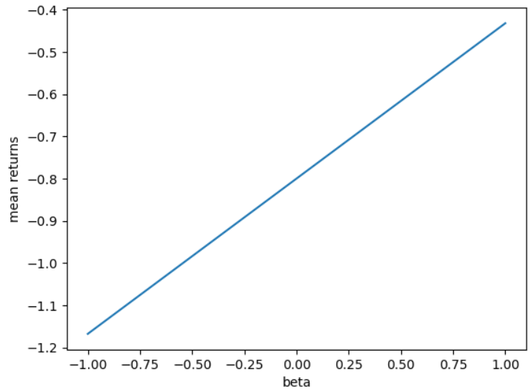
d) µ= (µ_{M} - µ_{rf})β+ µ_{rf}
Here
µ_{M}=-0.432
σ_{M}=0.0132

